1) What are thermochromic materials?
__________________________________________________________________________________________________________________________________________________________________________________________________________________________________________________________________________________________________________________________________________________________________________________________________________________________

2) How are they useful?
__________________________________________________________________________________________________________________________________________________________________________________________________________________________________________________________________________________________________________________________________________________________________________________________________________________________

3) Explain how thermochromic materials work
__________________________________________________________________________________________________________________________________________________________________________________________________________________________________________________________________________________________________________________________________________________________________________________________________________________________

4) What is meant by the term critical temperature?
__________________________________________________________________________________________________________________________________________________________________________________________________________________________________________________________________________________________________________________________________________________________________________________________________________________________

5) What factors can cause a change in an animal’s body temperature?
__________________________________________________________________________________________________________________________________________________________________________________________________________________________________________________________________________________________________________________________________________________________________________________________________________________________

6) Explain how to make a thermochromic collar
__________________________________________________________________________________________________________________________________________________________________________________________________________________________________________________________________________________________________________________________________________________________________________________________________________________________

7) Was the collar effective? Explain why/why not
____________________________________________________________________________________________________________________________________________________________________________________________________________________________________________________________________________________________________________________________________________________________________________________________________________________________________________________________________________________________________________________________________________________________________________________________________________________________________________________________________________________________________________________________________________________________________________________________________________________________________________________

Recorded results:

Experiment title: _________________________________________________________________
Date: __________________________________________________________________________
Lab Partner(s): __________________________________________________________________
Critical temperature used:__________________________________________________________
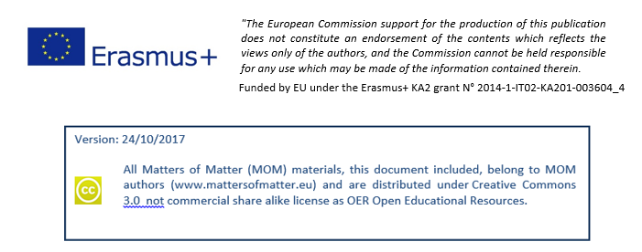
Time (minutes) | Colour Change Observed

