Tools for Materials Science - Challenge n°7 - 40’
UV Filtering Materials
The sun radiates energy in a wide range of wavelengths, most of which are invisible to human eyes. The shorter the wavelength, the more energetic the radiation, and the greater the potential for harm. Ultraviolet (UV) radiation that reaches the Earth’s surface is in wavelengths between 290 and 400 nm; namely UV-A and UV-B:
- UVA: 400 nm - 320 nm
- UVB: 320 nm - 290 nm
- UVC: 290 nm - 100 nm
Since the mid-1970s, human activities have been changing the chemistry of the atmosphere in a way that reduces the amount of ozone in the stratosphere (the layer of atmosphere ranging from about 11 to 50 km in altitude). This means that more ultraviolet radiation can pass through the atmosphere to the Earth surface, particularly during certain periods of the year.
Besides health concerns, in everyday life fabrics and paper become brittle, fade in colour, or turn yellow when exposed to sunlight. Those changes are mainly due to exposure to the UV-light in solar radiation.
Last but not least Space exploration also calls for new materials able to filter strong UV radiation.
CAUTION!!! UV beam !!!
-> USE the yellow/brown UV filters to fix on top of glasses !
->Do NOT stare at the UV source !
-> Always close the box BEFORE turning the UV on !

- Sensor Calibration: On the desk you see two sensors:
- one UVB Vernier sensor to use with Logger Pro software;
- one UVM30A sensor to use with Arduino
- The UVB Sensor is an ultraviolet light sensor that responds primarily to UVB radiation (approximately 290 to 320 nm). It is ideal for experiments using sunlight as your UV source
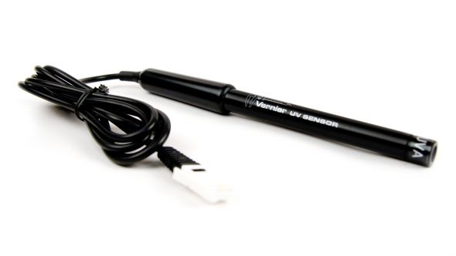
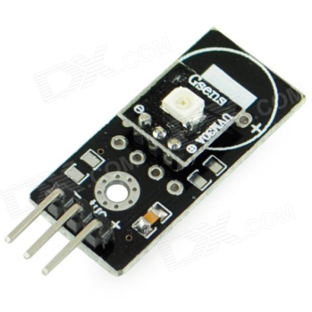
- The UVA Sensor is an ultraviolet light sensor that responds primarily to UVA radiation (approximately 320 to 390 nm). This sensor is ideal for experiments using UV lamps.

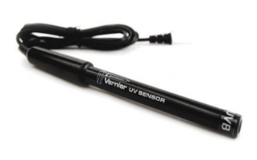
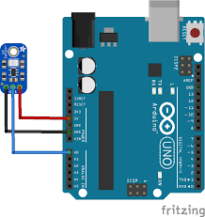
See the picture below for details on how to connect the sensor to Arduino.
Before testing samples about their UV filtering properties, we want to make sure that our cheap UV sensor is well calibrated and working correctly.
Therefore we will compare and graph the values read by the two sensors versus distance from the UV source (namely a UV bulb lamp).
With the UV filter on you should get the minimum value for the signal (is it really zero?).

- Testing samples – Once calibration is over insert the sensor UVM30A in the wooden box on the desk at the opposite end to the UV lamp. In the middle you will put the samples to test their UV filtering level. Here’s a list of possible samples to test:
- UV sun glasses or filters to apply to the glasses
- T-shirt: “normal”
- T-shirt: anti UV
[Compare the last two results: any difference?]
- Glass: normal
- Glass: quartz
[Compare the last two results: any difference?]
- Plexiglass: “normal”
- Plexiglass: anti UV (different kinds included the IR filtering one)
[Compare the last two results: any difference?]
- Photoluminescent (Fluorescent) plastic
- Sun screen cream – protective factor: 10 (on plexiglass or plastic sheet)
- Sun screen cream – protective factor: 50 (on plexiglass or plastic sheet)
[Compare the last two results: any difference?]

OUTPUT WANTED:
-> Comparison data (Table 1) and graph for calibration of the two sensors.
-> Percent of incident UV transmitted by each sample (Table 2)

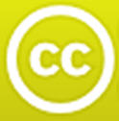 | All MoM-Matters of Matter materials, this sheet included, belong to MoM Authors  (www.mattersofmatter.eu) and are distributed under Creative Commons 4.0  not commercial share alike license as OER Open Educationa lResource

Answer sheet GROUP N°___________
Ch.7 --- UV Filtering Materials
Table 1 Calibration.
Distance  from UV source | Intensity of UV measured
 | UVB Vernier sensor | UVM30A sensor
Unit: | Unit: | Unit:
Report on a graph each point individuated by the couple of corresponding measures of UV-intensity made with the 2 sensors and draw the calibration curve.
Table 2 Testing
Sample Tested | Intensity of UV measured |  | % UV transmitted
 | I₀  without the filter | I  with the filter | = I / I₀ x 100
 | Unit: | Unit: | %
1
2
3
4
5
6
7
8
9
10

It’s a special glass UV filter

