Tools for Materials Science - Challenge n° 9- 40’
Optical Active Materials
What does optically active material mean?
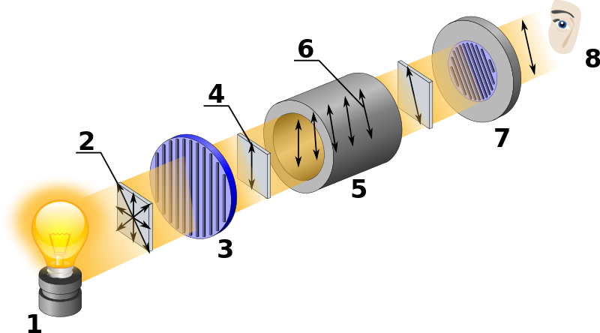
- Light Source
- Unpolarized light
- Polarizer
- Polarized light
- Optically active material
- Rotated polarized light with specific rotation
- Movable analyser
- Observer

Source: By Kaidor [CC BY-SA 3.0 (https://creativecommons.org/licenses/by-sa/3.0) or GFDL (http://www.gnu.org/copyleft/fdl.html)], via Wikimedia Commons-https://upload.wikimedia.org/wikipedia/commons/5/5d/Polarimeter_%28Optical_rotation%29.svg
Looking at the picture above you can see a schematization of what is polarized light: the beam of white light oscillates lying on all the plans perpendicular to direction of propagation of the beam; then the beam goes through the polarizing filter, the light oscillates on only one definite plan (which is determined by the polarizer axis).
This plan is rotated, as shown in the above picture, by the action of the material that, exactly for this reason, is called optically active. We call analyzer the second polarizing filter because it allows us to see what has happened.

Introduction – 5'
On the desk you have a computer with a plastic sheet envelope on the lit screen, a roll of scotch tape and what seems to be a simple black plastic piece; the latter will act as "analyzer" because it actually is a polarizer.

1. Stick scotch pieces with different orientation, also superimposing, on the plastic sheet envelope.
Q1. How does the scotch appear if you look at it trough the polarizing filter?
Q2. Take a photo of this effect.
Scotch is an optically active material. Let's investigate this further.

Experience
You can see, next to you, a box with a covered front window and a lamp; this simulates the polarized light of the computer screen (the big black plastic piece covering the window is a polarizing filter). On the other side of the box there is a pipe through which you can watch the effect of a new optically active material, in fact now we're going to use cellophane for convenience.
You have at your disposal 4 layers of cellophane and a black analyzer on a structure that you can assemble and disassemble very easily. On the analyzer you can see two letters: D and L that indicate the positions in which respectively you see the minimum(Dark)/maximum light brightness.

2. Set the analyzer on position D.
Q3. Do you really see total Darkness through the tube?
Q4.Can you explain why?

Keep the analyzer on D.
3. Put one cellophane sheet in the structure between window and analyzer and rotate it till the coloured arrow is on 0°. Now look through the tube.
Q5.What do you see?
4. Test one by one all the cellophane sheets.
Q6. Do you think they are all alike?
5. Now one of you should rotate the analyzer from 0° to 360° while somebody else will watch through the tube.
Q7. What do you see?
You have just verified the rotation of the plan of polarization ( Why can we say that?) .
Let's examine which are the important parameters :

Keep the analyzer on L and the cellophane on 0°.
6. Use the same structure of the previous issues (1 layer of cellophane).
Q8. What colour is the light you see?
Since the polarizers axis are aligned, it means that your eyes are seeing only the light whose plan of polarization has not undergone rotation.
7. Rotate by 90° the analyzer.
Q9. What colour do you see now?

Q10. For what you answered in Q9 and what you have seen rotating the analyzer can you say you have found a first dependence of the plan of polarization? Which one and why ? (Remember that different colour corresponds to a different wavelength of the light)

Keep the analyzer on B and the cellophane on 0°.
8. Add one by one more cellophane layers.
Q11. What do you observe? [Fill in the Table on the Answer sheet]

Q12. What can you deduce about the second dependence of the rotation of the plan of polarization? [Think also of the first experience with the scotch]

OUTPUT WANTED: answers to Q1 … Q12
Answer sheet GROUP N°___________
All MoM-Matters of Matter materials, this sheet included, belong to MoM Authors (www.mattersofmatter.eu) and are distributed under Creative Commons 4.0 not commercial share alike license as OER Open Educational Resources

Ch.9 --- Optical Active Materials
Q1

Q2: PICTURES [Sent by Whatsapp to your group – See general instruction to share pictures or files]

Q3

Q4

Q5

Q6

Q7

Q8

Q9

Q10

Q 11
Layers | Colour
1
2
3
4
Q12

All MoM-Matters of Matter materials, this sheet included, belong to MoM Authors (www.mattersofmatter.eu) and are distributed under Creative Commons 4.0 not commercial share alike license as OER Open Educational Resources

