Materials Decathlon - Challenge n°3 - 40’
Unusual Conductive Materials
Technology and its applications require lighter, cheaper, more versatile new conductive materials. Thanks to Materials Science, nowadays conductive plastic, ceramic and even glass can be manufactured.
- New conductive materials - On the desk you have a few mixed samples: which of them in your opinion are conductive?
- Now check your answers testing the samples with the multimeter in ohmmeter modality: if you can measure any electrical resistance then current is going through and the material is an electrical conductor. [Suggestion: test on both sides (top and bottom) and also along the vertical axis (putting one jack on each of the two sides).]
Q1.Would you like to change some of the answers given in step1? Fill in Table 1 on the answer sheet.
- Isotropic and anisotropic conductors- Consider samples A (plastic), B (glass) and C (textile). Put one of the ohmmeter jacks in one spot and move the other one around in a circle of the same radius. Is the resistance the same along each direction? If the answer is yes then it means the conductor is isotropic that is to say conduction is the same in all directions.
- In the market you can now find the so called “Z-axis conductive tape“ used as an alternative to soldering in microelectronics and prototyping. Test the sample sticked on the plexiglass rectangular sheet.
Q2. Is there any resistance across the surface (X-Y plane)?
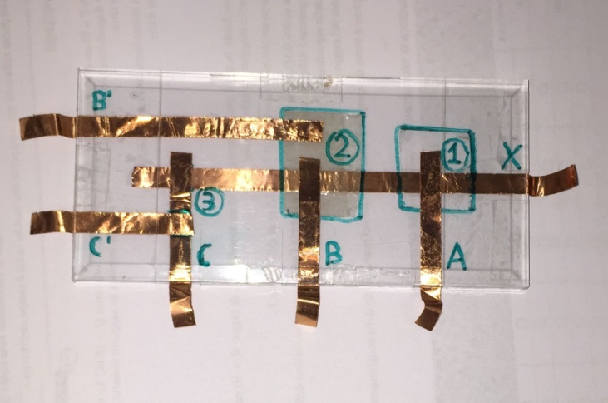
- Now consider the apparatus in the picture where in the junction between the copper strips there are different kinds of materials, conducting or not.
Link one of the ohmmeter crocodile jumpers to copper junction X (this will be fixed) and the second one in sequence to junction:
- A (common sellotape),
- B (Z-axis conductive tape)
- B’ (Z-axis conductive tape with misaligned copper strips)
- C (aligned copper strips)
- C’ (misaligned copper strips).
Q3. Which ones of the above junctions are letting current through?
Q4. What can you deduce about the Z-axis conductive tape? Is it isotropic or anisotropic?
- Now consider the two strips of conductive textiles: light grey (A) and dark (B). Split the team in two groups-one for each strip -and work separately though the following points
- Take note of the initial length L₀ and resistance R when the strip is at rest.
- Fix one of the extremities on the zero of a ruler and stretch the strip in 0,5 cm steps till you reach the maximum length while reading R. Fill in Table 2A and 2B with the data collected.
- Repeat two more times to check whether there’s correspondence in the values: calculate the mean value and evaluate the strip sensibility (error in measured resistance for a fixed elongation)
- Plot a graph of resistance versus elongation
Q5.Does resistance increase/decrease with increasing elongation?
Q6.To explain why the two kinds of textile act differently you may observe the knitting with the microscope. What can you see??

OUTPUT WANTED: answers to Q1-Q7 + Tables + Plots of Resistance versus Elongation for both strips

Answer sheet GROUP N°___________
Ch.3 --- Unusual Conductive Materials
Conductive | Not conductive
Q1 – Table 1:

Q2
Q3
Q4

Table 2A: light grey textiles |  |  |  |  |  | Table 2A: light grey textiles
Elongation | R | R | R | R |  | Elongation | R | R | R | R
= L – L₀ | 1st m. | 2nd m. | 3rd ms. | mean |  | = L – L₀ | 1st m. | 2nd m. | 3rd ms. | mean
cm | Ohm | Ohm | Ohm | Ohm |  | cm | Ohm | Ohm | Ohm | Ohm
Q5

Q6

Plot the two graphs either on paper or save them in a file if you used Excel – See general instruction to save files.
All MoM-Matters of Matter materials, this sheet included, belong to MoM Authors (www.mattersofmatter.eu) and are distributed under Creative Commons 4.0 not commercial share alike license as OER Open Educational Resources

